ShopiFy

1. Sign up your store at <http://www.shopify.com/>.

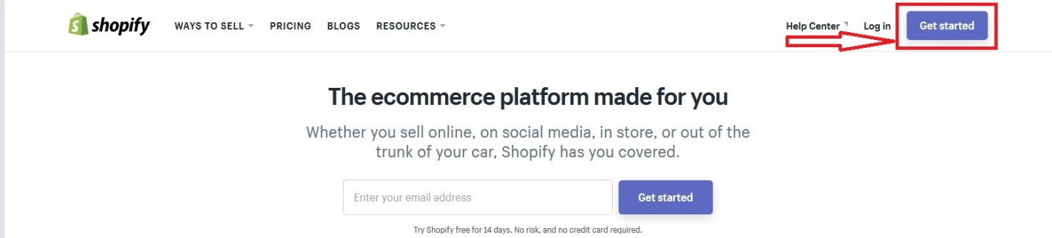

1. Enter your e-mail, password, Name of your store and click **Create your store**.

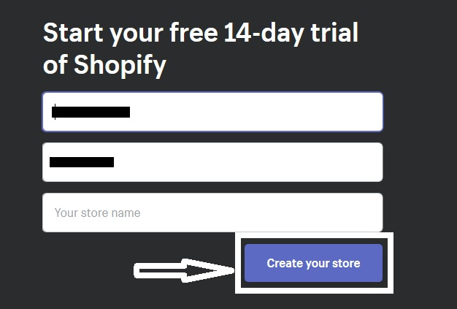

1. Then go on a page <https://www.shopify.com/partners> and sign up.



1. After you sign up, click **Apps.**

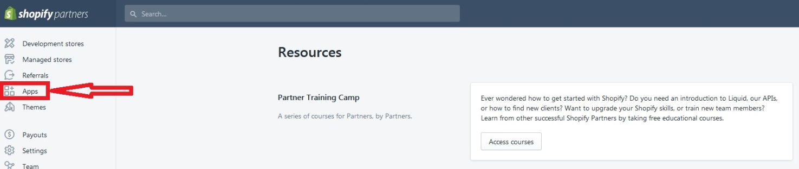

1. And click **Create app.**

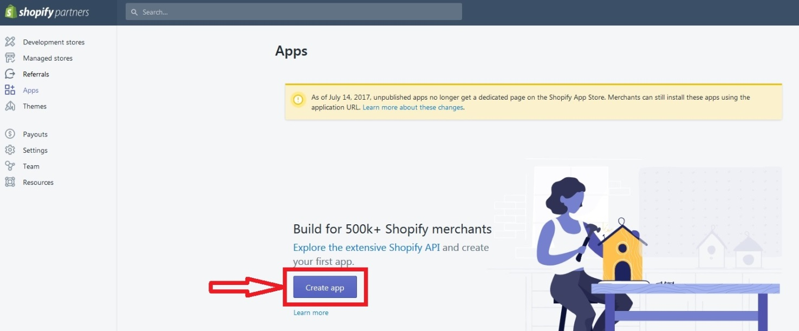

1. Fill out information and click **Create app.**

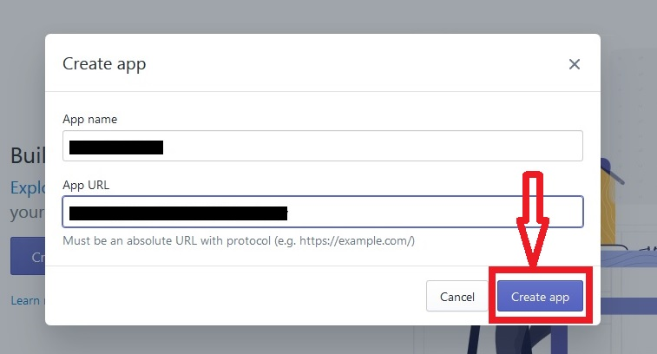

1. To get API key and API secret key, you need to go to the App info:

